**Agnieszka Katarzyna Cuprys [agnieszka.cuprys@nmbu.no](mailto:agnieszka.cuprys@nmbu.no)**

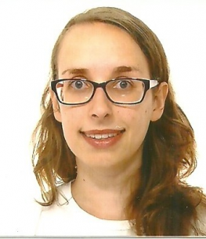Dr Agnieszka Cuprys is a Researcher in Water and Environmental Engineering at the Research Group on Smart Water (Water Treatment and Analytics), Faculty of Science and Technology, Norwegian University of Life Sciences -NMBU. She has an MSc in Pharmaceutical biotechnology (2016, Poland) and a PhD in Water Science (2019, Canada).

She was an EU-MSCA Post-doctoral fellow at the NMBU since 2021 before joining the research group as a Researcher and Project Management Specialist in 2023. Her research started with environmental biotechnology at the Institut National de la Recherche Scientifique (Quebec, Canada), with focus on the occurrence, fate and removal of emerging contaminants (pharmaceuticals and personal care products, PFAS, DBPs etc), which continues to this day.

Dr Cuprys contributing to the growth and management of the Water Harmony network, and is involved in several international projects funded by EU, Erasmus+ and the Norwegian Research Council.